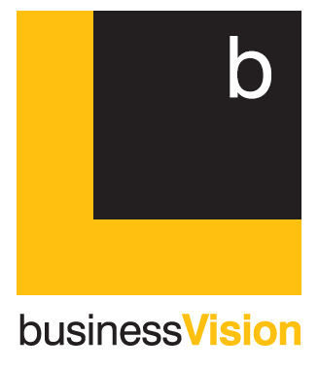

COVID support ceases

Support programs that ceased 30 September 2021
__________________________________________________

Many of the major support programs introduced by the government to help businesses during the pandemic ceased at the end of September 2021. This short update lists the major grants and concessions affected.

5% VAT on hospitality trades is increased to12.5%

Since July 2020, the rate of VAT that has applied to many services supplied by hospitality trades was reduced from 20% to just 5%. This reduction was extended to 30 September 2021.

From 1 October 2021 to 31 March 2022, the 5% rate will be replaced by a 12.5% rate.

Affected VAT registered traders will need to update their VAT software to account for this rate change.

The 12.5% rate is a new VAT rate. For the first time we have four rates of VAT; 0%, 5%, 12.5% and 20%.

From 1 April 2022, it is assumed that rates for the hospitality sector will return to 20%.

However, during these turbulent times, we can take nothing for granted.

The furlough scheme has ended

The job-saving Coronavirus Job Retention Scheme has ended. The last claim that can be made is to 30 September 2021.

Self-Employed Income Support Scheme (SEISS)

The SEISS has closed. The final claim was for the five months to 30 September 2021.

Universal Credits

Amid much commentary in the press, the £20 uplift ended 6th October 2021. However, the actual date claimants will experience a reduction in their payments will depend on the day they usually receive Universal Credit. Again, government may bow to pressure and delay this date or make the £20 a permanent increase in benefits. At the present time, claimants will need to adjust to a reduced payment.

Please call if you need more information regarding these changes.

___________________________________________________________________

Contact Us
support@marclawson.co.uk
01752 752210
Unit 4, Sandy Court, Ashleigh Way,
Plympton, Plymouth, PL7 5JX
www.bvisionaccountants.co.uk

