BLOGS, SOCIAL MEDIA, NEWSLETTER OR EMAIL ARTICLE

MEMBERS BRIEFING NOTE AND RELEASE FOR CLIENTS
CORONAVIRUS JOB RETENTION SCHEME: STEP BY STEP GUIDE FOR EMPLOYERS

Written 18 April 2020

(Note: please edit last sentence as per your billing intentions: Pro bono, per employee, fixed price, hourly rate)

For immediate release:

CORONAVIRUS JOB RETENTION SCHEME: STEP BY STEP GUIDE FOR EMPLOYERS

The Government has issued its guide that the information that employers need to provide to claim for their employees’ wages.

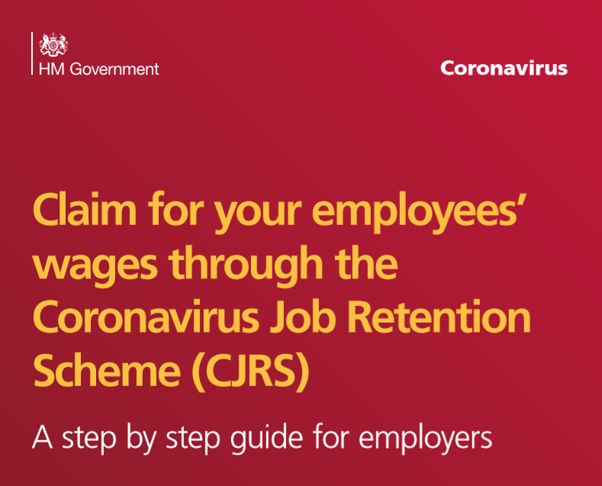

The full guide can be found:
https://assets.publishing.service.gov.uk/government/uploads/system/uploads/attachment_data/file/880092/Coronavirus_Job_Retention_Scheme_step_by_step_guide_for_employers.pdf

The step by step guide will take claimants through five sections:
- Step 1: Essential information
- Step 2: Before you make your claim
- Step 3: Calculating your claim
- Step 4: Making a claim
- Step 5: What to do next

Supporting the guide are pre-recorded webinars on HMRC YouTube channel: https://www.youtube.com/user/hmrcgovuk

Further information can be found on the GOV.UK Website: https://www.gov.uk/guidance/claim-for-wage-costs-through-the-coronavirus-job-retention-scheme
If you require assistance with your claim and would like us to help please contact us for a quote.

Ends.

